## Audit Log

The Audit Log provides access to a record of all user activity, including Session Start Time, User Name, and User Group when grouped by session; if grouped by user, it contains User Name, User Group, Address, and Phone Number.

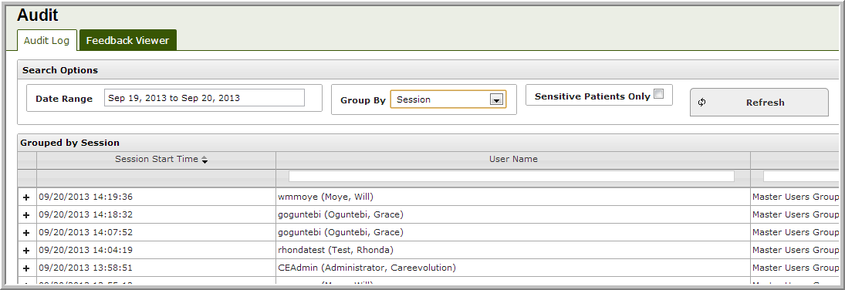

By default, the search start date is set to one day ago and the end date to the current day. Results are grouped by session. Clicking on the Date Range filter allows you to limit the results to any of the displayed ranges or to specify a different start and end date.

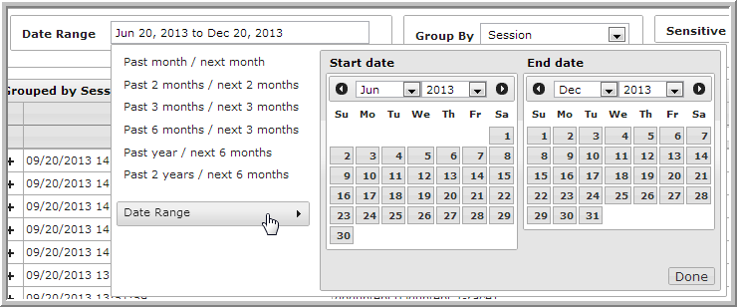

To sort by Start Time, click on the column header.

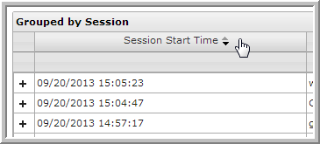

Search by user name or user group using the search boxes above the respective columns.

Note: You must enter the entire user name/group when searching.

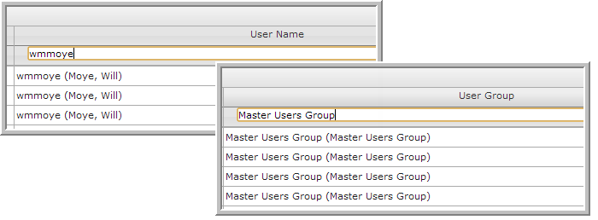

Select the*Sensitive Patients Only*checkbox and then **Refresh** to filter by users who have viewed sensitive records. To return to the previous view, uncheck the box and hit **Refresh** again.

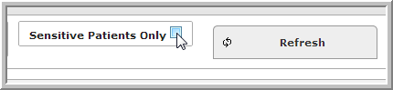

Click on the **+** sign beside the session to view the details of an event.

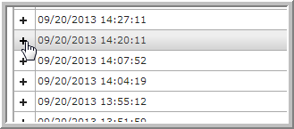

Click on any of the headers to sort by column.

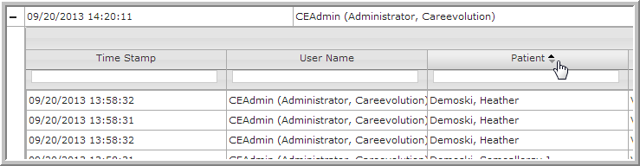

Each log event includes session start time, user name, patient viewed, actions performed by the user, details (including page duration), and applications viewed.

